

OPERATION ACTIVE RESOLVE INTELLIGENCE SUMMARY D7

# General Information

This intelligence summary covers the last 24 hours (From D7).

# Intelligence

## Air

### Russia and Syria agree to a oil for aircraft program

Credible recent reporting indicate that Russia have agreed to transfer additional aircraft to Syria while Syria pays back in oil to Russia. Reporting indicate that Russia is considering selling a newer MiG-29 version than the MiG-29A the Syrians currently have in stock.

**ASSESSMENT:**

It is LIKELY that last days attrition of the Syrian air force have caused a panic in the Syrian high command about their ability to control the skies. It is LIKELY that Syria will use any means necessary to try to establish air superiority in the southern regions to prevent any allied incursion into the Damascus area.

## Sea

### Surface Action Groups enroute EMED

Russian Surface Action Group (SAG) and Chinese SAG are still enroute the Eastern Mediterranean (EMED) and is expected to arrive in the EMED early during D8. VID have been unable to collect information about the composition of the different maritime groups to understand what kind of threat they pose to allied operations. VID have received allied reporting of a significant activity about to take place in the EMED.

**ASSESSMENT**:

Current assessment is that it is LIKELY that activity we reported above are that Chinese and Russian SAGs will conduct joint and combined training in the southern part of EMED.

## Ground

### Syrian border defenses

VID have credible reporting on Syrian border defenses. Syrian forces have created a strong border defense in certain areas. This consist of minefields and barriers making the areas nearly impossible to penetrate for conventional ground forces.

See picture below for areas:

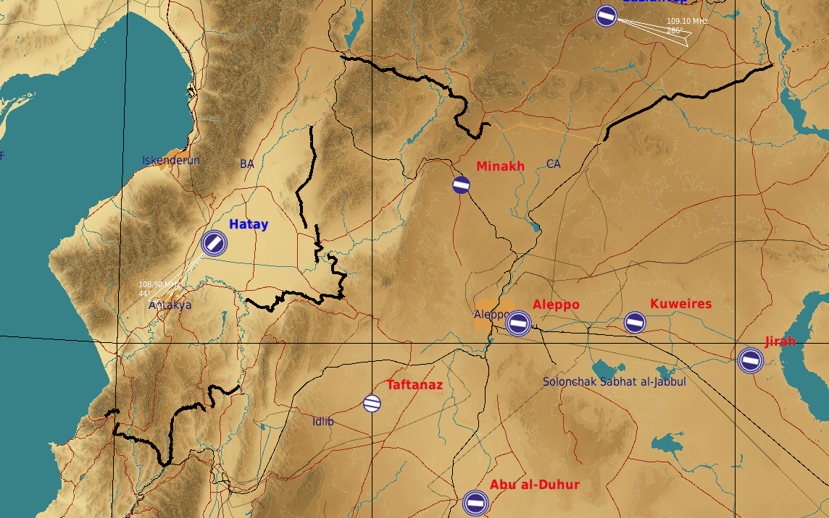

**ASSESSMENT:**

VID assess it as LIKELY that the Syrian ground forces will take this into consideration when planning their defenses in the border region.

*ADMIN COMMENT:*

The areas shown above have a concrete wall in the mission editor (placed there by the creators of the Syria map). The wall is not possible to transit through or destroy. So the intelligence above is the best way to take it into account.

### Syrian now occupies Sanliurfa airfield

The last 24 the Syrian ground forces have made significant progress toward the local Turkish forces protecting the Sanliurfa area. During the night the Syrian forces were able to break to the defenses and are now controlling Sanliurfa airfield.

## Political

NSTR

# VID Intelligence gaps

* VID_IR_1: What is the Syrian readiness for conducting attacks with WMD?
* VID_IR_2: What is the status and disposition of Syrian SCUD units?
* VID_IR_3: What is the status and disposition of Syrian Naval units?
* VID_IR_4: What is the status of Syrian Air Force
  + DCA missions? (Does the Syrian Air Force fly CAPs?)
  + QRA (reaction times?, from what bases? type of aircrafts?)
* VID_IR_5: What is the status of Syrian Air Force A-G missions?
* VID_IR_6: Is there presence of Russian forces in either Tartus or Bassel Al-Assad airfield?
* VID_IR_7: What is the status of Syrian IADS?
  + Positions of EWR
  + Position of SAM sites
  + Is the entire IADS operational?
* VID_IR_8: Are Russian aircraft moving into bases in Egypt?
  + What type of aircraft?
  + How do Russian aircraft operate out from Egypt?
* VID_IR_9: How will Russia and Syria enforce embargo?
  + What are the sources of the attack against logistics ship?
  + What assets can be used for blockade of allied ships?
* VID IR_10: Where will 5th Corps deploy to?
* VID IR_11: What is status and disposition of Syrian 6th Corps
  + What are the composition of 6th Corps
  + How long until 6th Corps are combat ready
* VID IR_12: What is composition of Chinese SAG?
* VID IR_13: What is composition of Russian SAG?